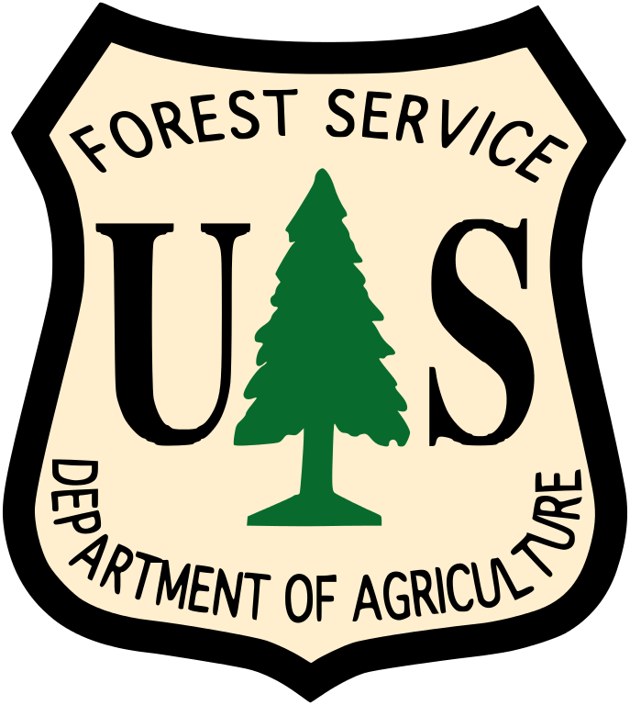
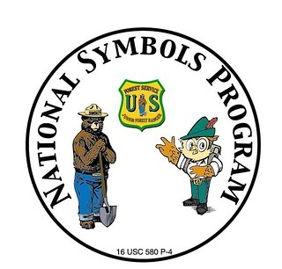
Announcing 2022-2023
Smokey Bear and Woodsy Owl
Youth Poster Contest

To: WSFGC District Directors

Children from first through fifth grade are invited to participate in Fall 2022 for the 2023 Youth Poster Contest sponsored by National Garden Clubs, Inc and US Forest Service.

National Garden Clubs, Inc. Poster Contest!
The U.S. Department of Agriculture Forest Service and the National Garden Clubs, Inc. is allowing students to demonstrate their understanding of wildfire prevention through original drawings of Smokey Bear.

Smokey Bear Says: ONLY YOU CAN PREVENT WILDFIRES!
Smokey Bear is recognized nationally and internationally as the symbol of wildfire
Prevention. The original Smokey Bear appeared in 1944. Smokey’s message, “Only You Can Prevent Wildfires!” encourages personal responsibility for wildfire prevention. Smokey Bear teaches children and adults to be careful with campfires, barbecues, trash fires, and matches.

Woodsy Owl Says: LEND A HAND—CARE FOR THE LAND!
Woodsy Owl is America’s loon for the conservation of the environment. Since 1971, Woodsy has helped parents and teachers inspire children to observe, explore, and care for the environment. He challenges children to “Lend a Hand, Care for the Land!” and to take an active role in caring for the land through recycling, reusing, and reducing waste, planting, and caring for trees, using resources wisely, and not littering.

All posters and local chairman reports are due to WSFGC Poster Chairman by January 2, 2023.
Mail to Chairman Evie Marwood at
12711 11th Ave NW, Seattle, WA 98177, Call, or text 206-519-7431.

Links are provided for Guidelines, Rules, and Timelines for this Poster Contest.

Announcement: poster-contest-announcement.pdf (gardenclub.org)
Rules: poster-contest-rules.pdf (gardenclub.org)
Timeline: poster-contest-timeline.pdf (gardenclub.org)
US Forest Service Volunteer Options: Home | US Forest Service (usda.gov)
Local Chairman Reports are due to WSFGC Chairman by January 2, 2023,
poster-contest-local-chairman-report.pdf (gardenclub.org)

