WSFGC ALSO OFFERS AFFILIATE
MEMBERSHIP TO:
Plant Societies
Public Gardens
Youth Affiliates
Junior Gardeners
Intermediate Gardeners
High School Gardeners
Arranger Guilds
Judges Councils
Washington Consultants Council
International Affiliates

Annual Membership dues for Affiliates is nominal; Adult Affiliates Members pay dues of $15 per year and Youth Affiliate Sponsors pay dues of $10 per year.
Application for Garden Club or Affiliate Membership is simple:
- Call or email WSFGC Membership Chairman, Judy Swortz at 253-582-0373 or 253-359-4285 or judyswortz@comcast.net.
- Complete the Membership Application Form available at https://www.wagardenclubs.com/clubs-membership
- Send your completed form and membership dues to Daphne Ruxton, WSFGC Dues Secretary at
802 Cultus Mountain Drive, Sedro-Woolley, WA 98284, rdas2duck@gmail.com.

For additional information contact Anne Sullivan, WSFGC President 360-240-0560, absullivan@comcast.net.
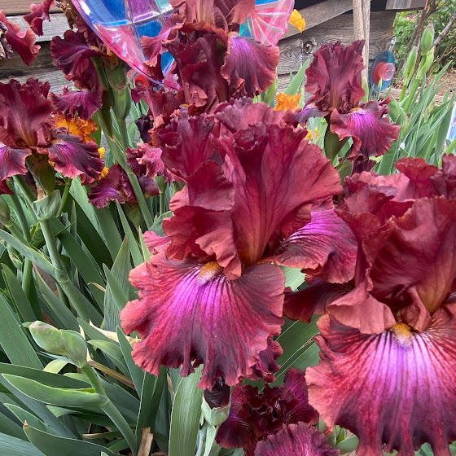
Come GROW With Us!
Learn the benefits of your Garden Club or Affiliate becoming a member of the
Washington State Federation
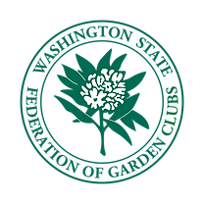
of Garden Clubs

WHY SHOULD MY CLUB JOIN THE WSFGC?

The Washington State Federation of Garden Clubs is a member of the Pacific Region Garden Clubs (7 western states) and National Garden Clubs, Inc. Globally there are approximately 165,000 members. Each is a designated 501(c)3 nonprofit organization. Your Garden Club members receive benefits from all three.

Washington State Federation of Garden Clubs - Benefits include being part of a group of over 2,000 clubs meeting regularly to share their passion for gardening, floral design, continuing education, civic projects and more. www.wagardenclubs.com.
Federation and locally sponsored continuing education - National Garden Club Environmental, Flower Show, Landscape Design, and Gardening Schools. Symposium. Leadership training, business skills, team building.
Annual Membership dues for Garden Clubs are nominal; $10.00 per club plus $5.00 per member in each club.
WSFGC Liability Insurance – Clubs are covered by an umbrella policy. Annual cost to WSFGC is approximately $5,000.
Grants for Clubs/Districts – up to $1,000 per grant, $10,000 available annually.
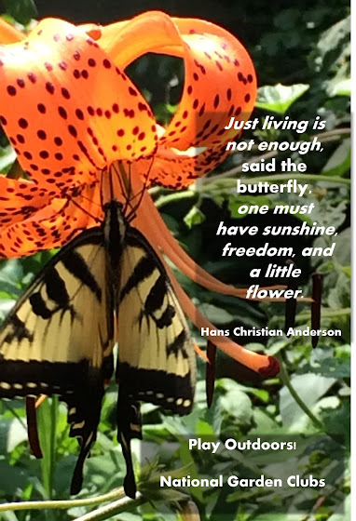
WSFGC Scholarships Seven, $2,000 scholarships are given to college students for related educational programs.
Conventions and Federation Flower Shows
Washington State Natural Disaster Fund – Districts or clubs may request up to $1,000 per fiscal year for a natural disaster in their area
The WSFGC makes Charitable contributions to public Washington arboretums/public and botanical gardens/other non-profit organizations with a conservation or environmental focus
Federation, Regional and National Awards for community beautification, conservation, flower show achievement, organic growing, youth education, poetry, essay and art contests, publications and more.
Access to free quarterly publications Washington Garden and Design, and WACONIAH
WSFGC Quarterly Board meetings - Fellowship, flower shows, workshops, programs.
Collaboration with other Districts, Clubs, and individuals
Access to Environmental, Gardening, Landscape design and Flower Show Consultants and experienced Speakers.

